CCNA SRWE Practice Lab
Part 2 — Access-Layer VLAN Security, Multi-Site Static/Floating Routing (IPv4 & IPv6), DHCP, and Wireless Client Verification

1. Overview
This lab builds out a small multi-site topology: two HQ LANs (HQ B-1 and HQ B-2) behind the Central router, a Remote Office LAN behind Office-1, a Remote Branch LAN (wired users plus a wireless AP/laptop) behind Branch-101, and an ISP Router providing a path out to a simulated Internet host. The work covered here spans four areas: hardening access ports on switch S1-1 (VLANs, port security, DHCP snooping, Dynamic ARP Inspection, PortFast/BPDU Guard, and shutting down unused ports), configuring static and floating static routes — both IPv4 and IPv6 — on the Central and Branch-101 routers, standing up a DHCP server on Branch-101 for its own LAN while Branch-101 itself gets its WAN address from DHCP, and confirming a laptop's wireless association to the branch access point.

Topology Reference
The addressing and roles referenced throughout this document:
- HQ B-1 LAN — 192.168.1.0/24, 2001:DB8:ACAD:1::/64 — switch S1-1, hosts PC-A and PC-B
- HQ B-2 LAN — 192.168.2.0/24, 2001:DB8:ACAD:2::/64 — switch S2-2, hosts PC-C and PC-D
- Remote Office LAN — 192.168.3.0/24, 2001:DB8:ACAD:3::/64 — switch S3-1, PC-E and Server-01, behind Office-1
- Remote Branch LAN — Management 192.168.100.0/24, Users 192.168.10.0/24 — switch S4-1, WLC-10, access point LAP-1 and its wireless Laptop, behind Branch-101
- Central — core router connecting HQ B-1, HQ B-2, Office-1, Branch-101 and the ISP Router; also hosts the RADIUS server and W-Admin Host segment
- ISP Router — connects the internal sites to the simulated Internet (www.ccnav7.pt at 203.0.113.25 / 2001:DB8:CAFE::25) via the Cloud
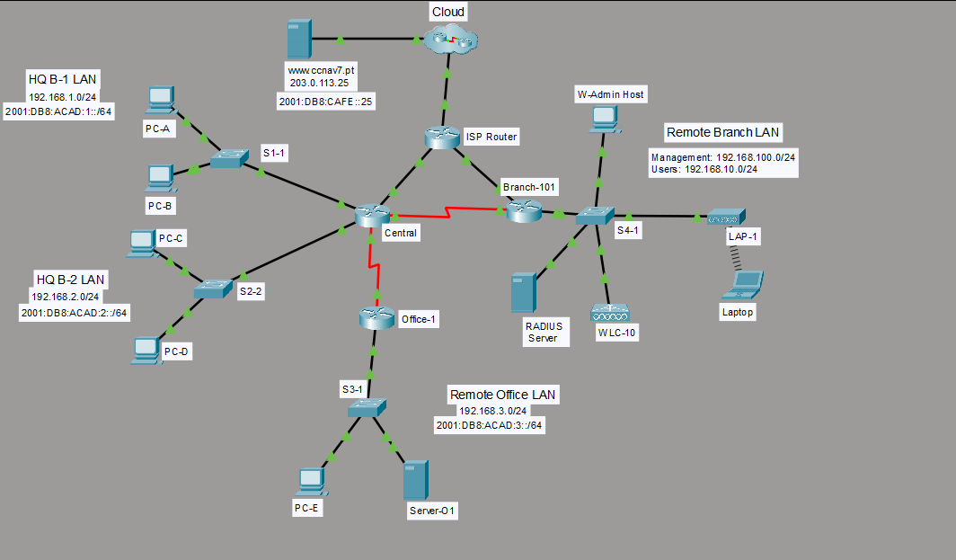
Figure 1. Full logical topology — Central, Office-1, Branch-101, ISP Router/Cloud, and all attached LANs.

2. Access-Layer Hardening on S1-1 (HQ B-1 Switch)
S1-1 is configured with two VLANs, port security on the user-facing access ports, DHCP snooping and Dynamic ARP Inspection to protect against rogue DHCP servers and ARP spoofing, PortFast with BPDU Guard on the access ports, and finally the unused ports are moved into a dedicated VLAN and administratively shut down.

2.1 VLAN Creation and Access Port Assignment

S1-1>enable
S1-1#config t
Enter configuration commands, one per line. End with CNTL/Z.
S1-1(config)#vlan 10
S1-1(config-vlan)#name users
S1-1(config-vlan)#vlan 99
S1-1(config-vlan)#name unused
S1-1(config-vlan)#interface range fa0/1-5, g0/1
S1-1(config-if-range)#switchport mode access
S1-1(config-if-range)#switchport acces vlan 10
S1-1(config-if-range)#interface range fa0/1-5
^
% Invalid input detected at '^' marker.

VLAN 10 ("users") is created for the active hosts and VLAN 99 ("unused") is reserved for ports that aren't in service — a standard practice so that any port left in the default VLAN 1 or accidentally patched in doesn't land on a live data VLAN. switchport acces vlan 10 (missing the final "s") still works because it's the shortest unambiguous abbreviation of access that IOS can resolve; the next line, re-entering interface range fa0/1-5 while already inside that same range context, is what actually triggers Invalid input, since IOS doesn't accept a second interface range command stacked directly on top of the current interface sub-configuration in that form.

2.2 Port Security

S1-1(config-if-range)#interface range fa0/1-5
S1-1(config-if-range)#switchport port-security
S1-1(config-if-range)#switchport port-security maximum 4
S1-1(config-if-range)#switchport port-security violation restrict
S1-1(config-if-range)#switchport port-security aging time 10
S1-1(config-if-range)#switchport port-security mac-address sticky
S1-1(config-if-range)#interface fa0/1
S1-1(config-if)#switchport port-security mac-address 00D0.D3DC.2825
S1-1(config-if)#exit

Port security is enabled on Fa0/1-5 with a maximum of 4 learned MAC addresses per port, violation mode set to restrict (traffic from a MAC address beyond the limit is dropped and a syslog/SNMP notification is generated, but the port itself stays up — unlike shutdown mode, which would err-disable it), and a 10-minute aging timer so stale entries eventually clear. mac-address sticky converts dynamically learned MACs into entries saved to the running configuration automatically. On Fa0/1 specifically, one MAC address (00D0.D3DC.2825) is also statically defined, which pins that address to the port regardless of what sticky learning would otherwise pick up.

2.3 DHCP Snooping and Dynamic ARP Inspection

S1-1(config)#ip dhcp snooping
S1-1(config)#ip dhcp snooping vlan 10,999
S1-1(config)#interface range fa0/1-5, g0/1
S1-1(config-if-range)#ip dhcp snooping limit rate 5
S1-1(config-if-range)#exit
S1-1(config)#interface g0/1
S1-1(config-if)#ip dhcp snooping trust
S1-1(config-if)#exit
S1-1(config)#ip arp inspection vlan 10,999
S1-1(config)#interface g0/1
S1-1(config-if)#ip arp inspection trust
S1-1(config-if)#interface range fa0/1-5

ip dhcp snooping turns the feature on globally, then ip dhcp snooping vlan 10,999 scopes it to the VLANs in use (note VLAN 999 is referenced here even though the access ports created earlier used VLAN 99 — worth double-checking against the intended design, since 99 and 999 are easy to transpose and DHCP snooping/DAI won't protect a VLAN that isn't explicitly listed). The access ports (Fa0/1-5) get a DHCP snooping rate limit of 5 packets/second to blunt DHCP-flooding attacks, while the uplink (G0/1) is marked trusted so legitimate DHCP server replies coming from upstream aren't discarded. Dynamic ARP Inspection is then enabled on the same VLAN list and G0/1 is trusted there too — DAI uses the DHCP snooping binding table to validate that ARP replies on untrusted (access) ports actually match a known IP-to-MAC binding, which is the standard defense against ARP spoofing/man-in-the-middle attacks on the local segment.

2.4 PortFast and BPDU Guard

S1-1(config-if-range)#spannin-tree portfast
^
% Invalid input detected at '^' marker.

S1-1(config-if-range)#spanning-tree portfast
%Warning: portfast should only be enabled on ports connected to a single
host. Connecting hubs, concentrators, switches, bridges, etc... to this
interface when portfast is enabled, can cause temporary bridging loops.
Use with CAUTION

%Portfast has been configured on FastEthernet0/1 but will only
have effect when the interface is in a non-trunking mode.
%Portfast has been configured on FastEthernet0/2 but will only
have effect when the interface is in a non-trunking mode.
%Portfast has been configured on FastEthernet0/3 but will only
have effect when the interface is in a non-trunking mode.
%Portfast has been configured on FastEthernet0/4 but will only
have effect when the interface is in a non-trunking mode.
%Portfast has been configured on FastEthernet0/5 but will only
have effect when the interface is in a non-trunking mode.
S1-1(config-if-range)#spanning-tree bpduguard enable
S1-1(config-if-range)#exit

spannin-tree is a typo for spanning-tree and is rejected. Once corrected, PortFast is applied to Fa0/1-5: IOS repeats its standard caution that PortFast should only go on ports with a single end host attached (never another switch or hub), because it skips the normal STP listening/learning delay and brings the port straight to forwarding — safe for a PC, dangerous for anything that could introduce a loop. bpduguard enable is the companion safeguard: if a PortFast-enabled port ever receives a BPDU (a sign a switch, not a host, got plugged in), the port is immediately error-disabled rather than silently breaking the PortFast assumption.

2.5 Unused Ports — Access VLAN 999 and Administrative Shutdown

S1-1(config)#interface range f0/6-24,g0/2
S1-1(config-if-range)#switchport mode access
S1-1(config-if-range)#switchport access vlan 999
% Access VLAN does not exist. Creating vlan 999
S1-1(config-if-range)#switchport access vlan 999
S1-1(config-if-range)#shutdown

All remaining ports (Fa0/6 through Fa0/24 and G0/2 — i.e., everything not already assigned to VLAN 10) are set to access mode and placed into VLAN 999. That VLAN didn't exist yet, so IOS auto-creates it on the fly ("Access VLAN does not exist. Creating vlan 999") — worth reconciling with the VLAN 99 ("unused") created back in Section 2.1, since this now leaves two separate "parking" VLANs (99 and 999) rather than one. Every one of these ports is then administratively shut down, which is the standard unused-port hardening step: a disabled port can't be used even if someone plugs into it, regardless of its VLAN membership.

%LINK-5-CHANGED: Interface FastEthernet0/6, changed state to administratively down
%LINK-5-CHANGED: Interface FastEthernet0/7, changed state to administratively down
%LINK-5-CHANGED: Interface FastEthernet0/8, changed state to administratively down
%LINK-5-CHANGED: Interface FastEthernet0/9, changed state to administratively down
%LINK-5-CHANGED: Interface FastEthernet0/10, changed state to administratively down
%LINK-5-CHANGED: Interface FastEthernet0/11, changed state to administratively down
%LINK-5-CHANGED: Interface FastEthernet0/12, changed state to administratively down
%LINK-5-CHANGED: Interface FastEthernet0/13, changed state to administratively down
%LINK-5-CHANGED: Interface FastEthernet0/14, changed state to administratively down
%LINK-5-CHANGED: Interface FastEthernet0/15, changed state to administratively down
%LINK-5-CHANGED: Interface FastEthernet0/16, changed state to administratively down
%LINK-5-CHANGED: Interface FastEthernet0/17, changed state to administratively down
%LINK-5-CHANGED: Interface FastEthernet0/18, changed state to administratively down
%LINK-5-CHANGED: Interface FastEthernet0/19, changed state to administratively down
%LINK-5-CHANGED: Interface FastEthernet0/20, changed state to administratively down
%LINK-5-CHANGED: Interface FastEthernet0/21, changed state to administratively down
%LINK-5-CHANGED: Interface FastEthernet0/22, changed state to administratively down
%LINK-5-CHANGED: Interface FastEthernet0/23, changed state to administratively down
%LINK-5-CHANGED: Interface FastEthernet0/24, changed state to administratively down
%LINK-5-CHANGED: Interface GigabitEthernet0/2, changed state to administratively down
S1-1(config-if-range)#end
S1-1#
%SYS-5-CONFIG_I: Configured from console by console
S1-1#

Every targeted port confirms administratively down, then end returns to privileged EXEC and the CONFIG_I message logs that the running configuration was changed from the console.
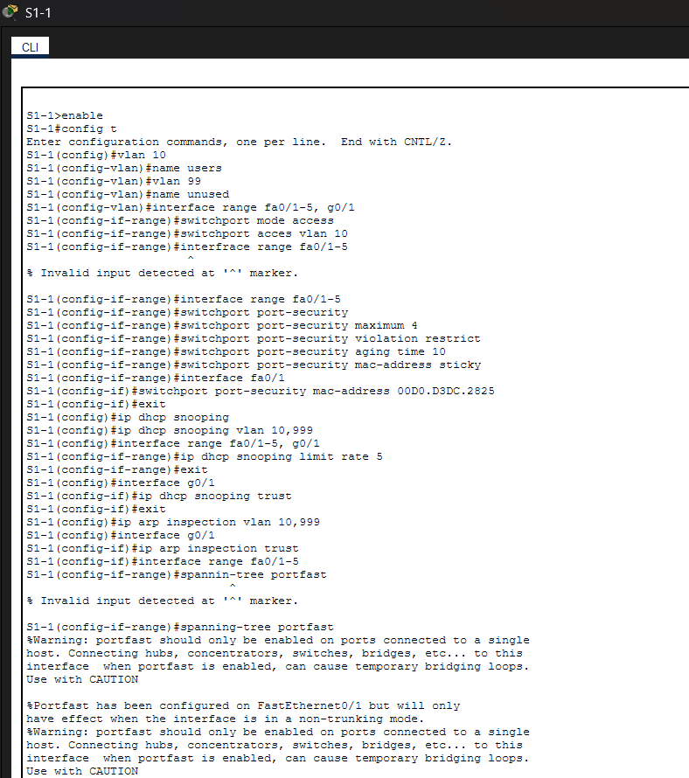
Figure 2. S1-1 — VLAN creation, access port assignment, port security, DHCP snooping and ARP inspection setup.
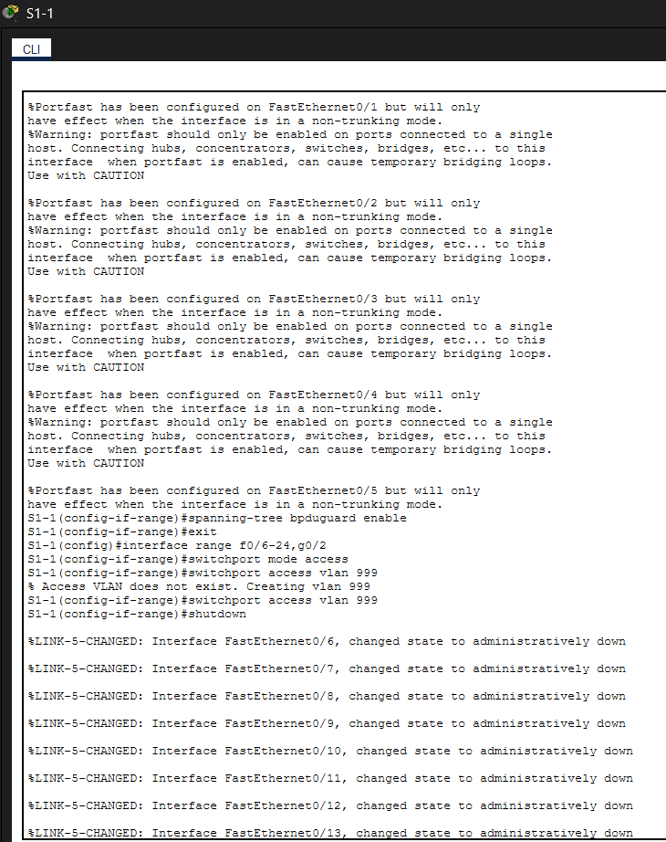
Figure 3. S1-1 — PortFast/BPDU Guard warnings, VLAN 999 auto-creation, and unused ports being shut down.
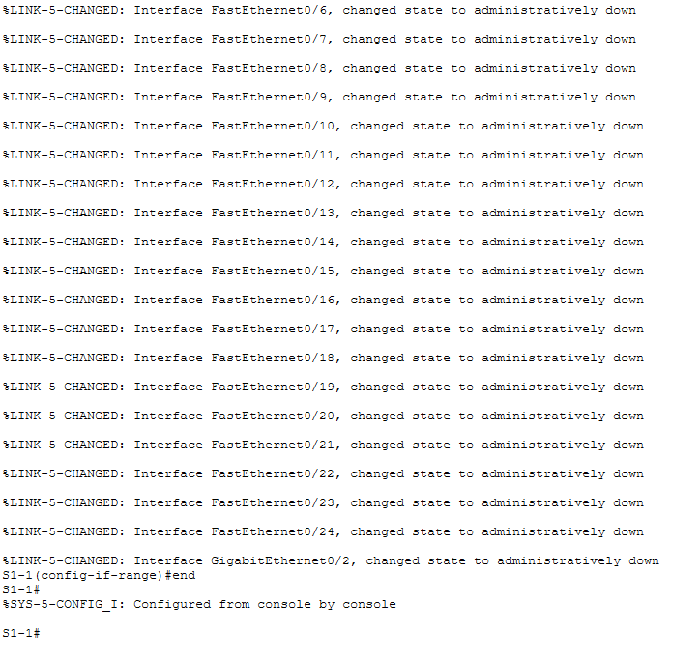
Figure 4. S1-1 — remaining unused ports confirmed administratively down and configuration saved from console.

3. Central Router — Static and Floating Static Routing (IPv4 & IPv6)
Central needs a route out to the Internet/ISP side and specific routes toward the Branch and Remote Office networks, with a working primary path and a backup (floating static) path for resilience.

Central>enable
Central#config t
Enter configuration commands, one per line. End with CNTL/Z.
Central(config)#ip route 0.0.0.0 0.0.0.0 g0/0/2
%Default route without gateway, if not a point-to-point interface, may impact performance
Central(config)#ip route 0.0.0.0 0.0.0.0 so/1/0 10
^
% Invalid input detected at '^' marker.

Central(config)#ip route 0.0.0.0 0.0.0.0 s0/1/0 10
Central(config)#ipv6 unicast-routing
Central(config)#ipv6 route ::/0 2001:DB8:ACAD:A::2
Central(config)#ipv6 route ::/0 2001:db8:acad:b::2 10
Central(config)#ip route 192.168.10.0 255.255.255.0 g0/0/2
Central(config)#ip route 192.168.10.0 255.255.255.0 s0/1/0 10
Central(config)#ip route 192.168.3.122n255.255.255. s0/1/1
^
% Invalid input detected at '^' marker.

Central(config)#ip route 192.168.3.122 255.255.255.255 s0/1/1
Central(config)#ipv6 route 2001:DB8:ACAD:3::122/128 2001:db8:acad:d::2
Central(config)#

3.1 Reading the configuration
- ip route 0.0.0.0 0.0.0.0 g0/0/2 — a default route pointed at an exit interface rather than a next-hop IP; IOS accepts it but warns, since a multi-access-capable interface (unlike a genuine point-to-point serial link) requires an extra ARP resolution step per destination, which can affect performance/behavior versus a next-hop route.
- so/1/0 is a typo for s0/1/0 and is rejected before the rest of the line is even parsed.
- ip route 0.0.0.0 0.0.0.0 s0/1/0 10 is the corrected line: a second default route via the serial interface with administrative distance 10. Since a normal static route defaults to AD 1 and this one is explicitly set higher (10), it acts as a floating static default — a backup route that only enters the routing table if the primary (lower-AD) default route via G0/0/2 goes away.
- ipv6 unicast-routing must be enabled globally before any IPv6 routes/forwarding will work — this is a one-time prerequisite command on IOS.
- The two ipv6 route ::/0 lines mirror the IPv4 pattern: a default route to next-hop 2001:DB8:ACAD:A::2 at the default AD, and a second default route to 2001:db8:acad:b::2 with AD 10 acting as the floating/backup IPv6 default.
- The 192.168.10.0/24 (Branch users) route is entered twice — once via g0/0/2 (default AD) and once via s0/1/0 with AD 10 — the same primary/floating-backup pattern applied to a specific destination network rather than just the default route.
- 192.168.3.122n255.255.255. is a typo (a stray "n" and an incomplete mask) and is rejected; the corrected line, ip route 192.168.3.122 255.255.255.255 s0/1/1, is a host route (/32) to a single address — typically used to route to a specific server, such as Server-01 on the Remote Office LAN, over a specific link.
- The matching IPv6 host route, ipv6 route 2001:DB8:ACAD:3::122/128 2001:db8:acad:d::2, applies the same /128 host-route logic to that server's IPv6 address.
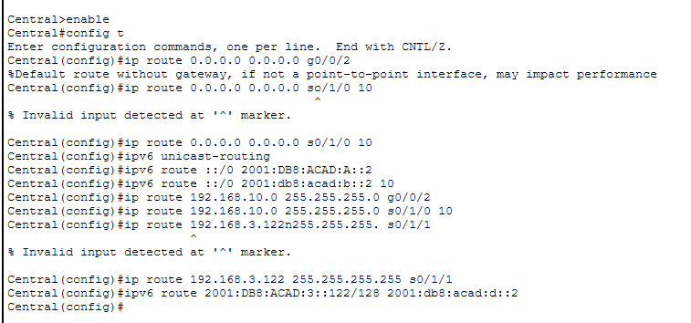
Figure 5. Central router — default and floating static routes (IPv4 and IPv6), plus host routes toward Server-01.

4. Branch-101 Router — Subinterface, DHCP Server, DHCP Client, and Routing

4.1 Router-on-a-Stick Subinterface and the DHCP Pool for the Branch LAN

Branch-101>enable
Branch-101#config t
Enter configuration commands, one per line. End with CNTL/Z.
Branch-101(config)#interface g0/0/0.10
Branch-101(config-subif)#
%LINK-3-UPDOWN: Interface GigabitEthernet0/0/0.10, changed state to down

%LINEPROTO-5-UPDOWN: Line protocol on Interface GigabitEthernet0/0/0.10, changed state to up

Branch-101(config-subif)#description Branch LAN

Branch-101(config-subif)#encapsulation dot1q 10
Branch-101(config-subif)#ip address 192.168.10.1 255.255.255.0
Branch-101(config-subif)#exit
Branch-101(config)#ip dhcp excluded-address 192.168.10.1
Branch-101(config)#ip dhcp excluded-address 192.168.10.254
Branch-101(config)# ip dhcp pool WLAN-hosts
Branch-101(dhcp-config)#network 192.168.10.0 255.255.255.0
Branch-101(dhcp-config)#default-router 192.168.10.1
Branch-101(dhcp-config)#dns-server 198.51.100.163
Branch-101(dhcp-config)#interface g0/0/1
Branch-101(config-if)#ip address dhcp
Branch-101(config-if)#
%DHCP-6-ADDRESS_ASSIGN: Interface GigabitEthernet0/0/1 assigned DHCP address 10.3.0.2, mask 255.255.255.252, hostname Branch-101

Subinterface g0/0/0.10 is created for VLAN 10 (the branch user VLAN), tagged with encapsulation dot1q 10, and given the gateway address 192.168.10.1/24 — a standard router-on-a-stick setup so a single physical link to S4-1 can serve a tagged VLAN. The subinterface briefly reports link down before its line protocol comes up, which is expected: a subinterface's line-protocol state tracks its parent physical interface. Two addresses are excluded from DHCP assignment (192.168.10.1, the gateway itself, and 192.168.10.254, likely reserved for another static purpose), and pool WLAN-hosts is defined to hand out addresses on 192.168.10.0/24 with default-router 192.168.10.1 and DNS server 198.51.100.163. Separately, on the WAN-facing interface g0/0/1, ip address dhcp configures Branch-101 itself to obtain its own address from an upstream DHCP server — it successfully leases 10.3.0.2/30, confirmed by the DHCP-6-ADDRESS_ASSIGN message. In other words, Branch-101 is simultaneously a DHCP client on its WAN side and a DHCP server on its LAN side.
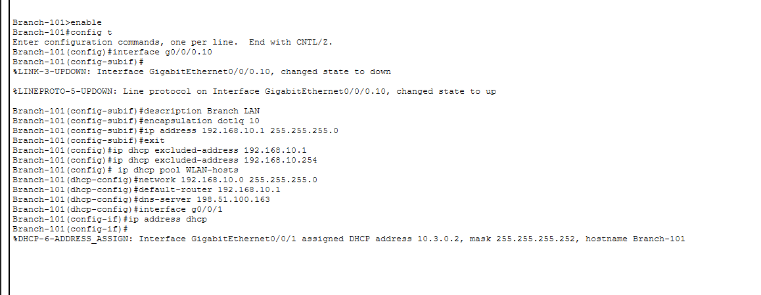
Figure 6. Branch-101 — VLAN 10 subinterface, DHCP pool for the branch LAN, and the WAN interface leasing an address via DHCP.

4.2 Default and Floating Static Routes (IPv4 & IPv6)

Branch-101>enable
Branch-101#config t
Enter configuration commands, one per line. End with CNTL/Z.
Branch-101(config)#ip route 0.0.0.0 0.0.0.0 g0/0/1
%Default route without gateway, if not a point-to-point interface, may impact performance
Branch-101(config)#ip route 0.0.0.0 0.0.0.0 s0/1/0 10
Branch-101(config)#ipv6 unicast-routing
Branch-101(config)#ipv6 route ::/0 2001:DB8:ACAD:A::
Branch-101(config)#ipv6 route ::/0 2001:db8:acad:b::1 10
Branch-101(config)#

Branch-101 mirrors the primary/floating-backup pattern seen on Central: a default route out g0/0/1 (its DHCP-addressed WAN interface, again triggering the interface-vs-next-hop warning) is treated as the primary path, with a second default route via s0/1/0 at AD 10 as the floating backup. The IPv6 side is the same shape — a primary ::/0 route and a backup ::/0 route at AD 10 — though the primary IPv6 next-hop here (2001:DB8:ACAD:A::) is written without a full interface identifier segment, which is worth double-checking against the intended next-hop address if this route doesn't behave as expected.
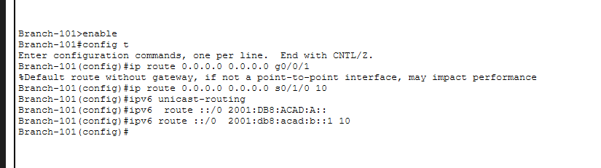
Figure 7. Branch-101 — primary and floating static default routes, IPv4 and IPv6.

5. Wireless Client Verification — Laptop to LAP-1
With the branch LAN and its DHCP pool in place, the Laptop's wireless adapter (a Linksys-style WPC300N Wireless-N Notebook Adapter) is checked against the access point LAP-1 in infrastructure mode.

Link Information
Infrastructure Mode
You have successfully connected to the access point
Signal Strength: (full)
Link Quality: (full)
Adapter is Active

The client confirms association with the AP ("You have successfully connected to the access point") in infrastructure mode — meaning the laptop communicates through LAP-1 rather than directly peer-to-peer (ad hoc) with another device. Signal strength and link quality both read full, indicating a clean RF connection in this simulated environment. From here, the laptop would be expected to pull an address from the WLAN-hosts DHCP pool configured on Branch-101 (Section 4.1) for the 192.168.10.0/24 branch user network.
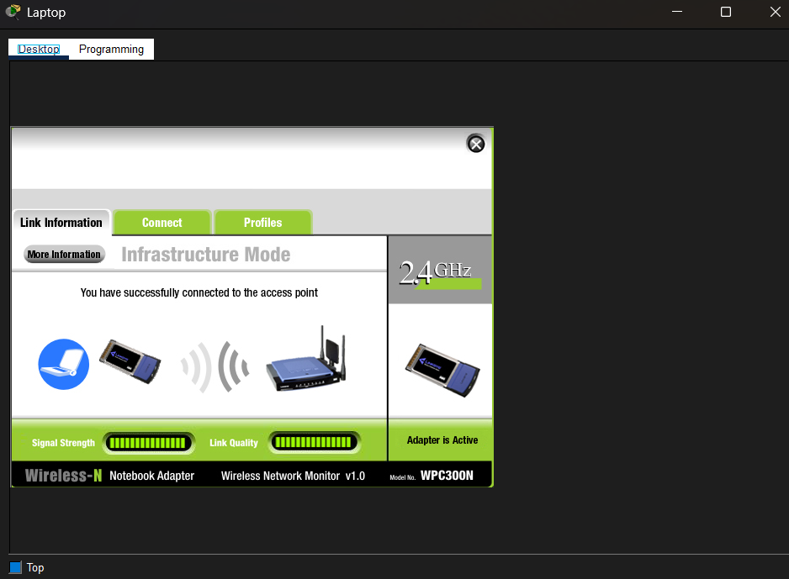
Figure 8. Laptop — successful wireless association to LAP-1 in Infrastructure Mode, full signal strength and link quality.

6. Summary of Key Takeaways
- Access-layer hardening on S1-1 combined five independent controls: VLAN segmentation, port security (limit + sticky MAC + restrict violation action), DHCP snooping with a trusted uplink, Dynamic ARP Inspection riding on the DHCP snooping binding table, and PortFast + BPDU Guard on end-host ports — plus shutting down and re-VLANing every port not actively in use.
- Double-check the VLAN 99 vs. VLAN 999 naming in Sections 2.1/2.4/2.5 and the truncated IPv6 next-hop in Section 4.2 — both are the kind of small inconsistency that's easy to introduce mid-lab and worth reconciling against the original design.
- A floating static route is simply a normal static route entered with a higher administrative distance than the primary path — it sits idle in the configuration until the primary route disappears from the routing table, then takes over automatically. This pattern was used for both IPv4 and IPv6, and for both default routes and specific-network routes.
- Host routes (/32 for IPv4, /128 for IPv6) are used on Central to reach a single address (Server-01) over a specific path, separate from the broader network-level routes.
- Branch-101 plays both DHCP roles at once: a DHCP client on its WAN uplink and a DHCP server for its own LAN — a common branch-router pattern.
- Wireless client verification confirmed Infrastructure Mode association to LAP-1 with full signal strength, the last link needed for the branch's wireless users to reach the DHCP pool and, from there, the rest of the topology.

